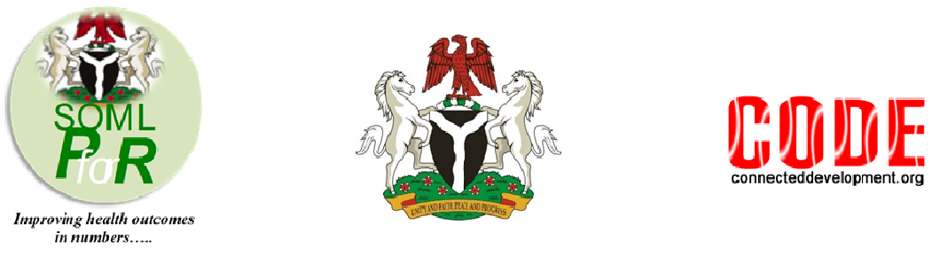
REPORT ON THE SAVING ONE MILLION LIVES PROGRAM FOR RESULTS (SOML PFORR) CSOs ROUNDTABLE

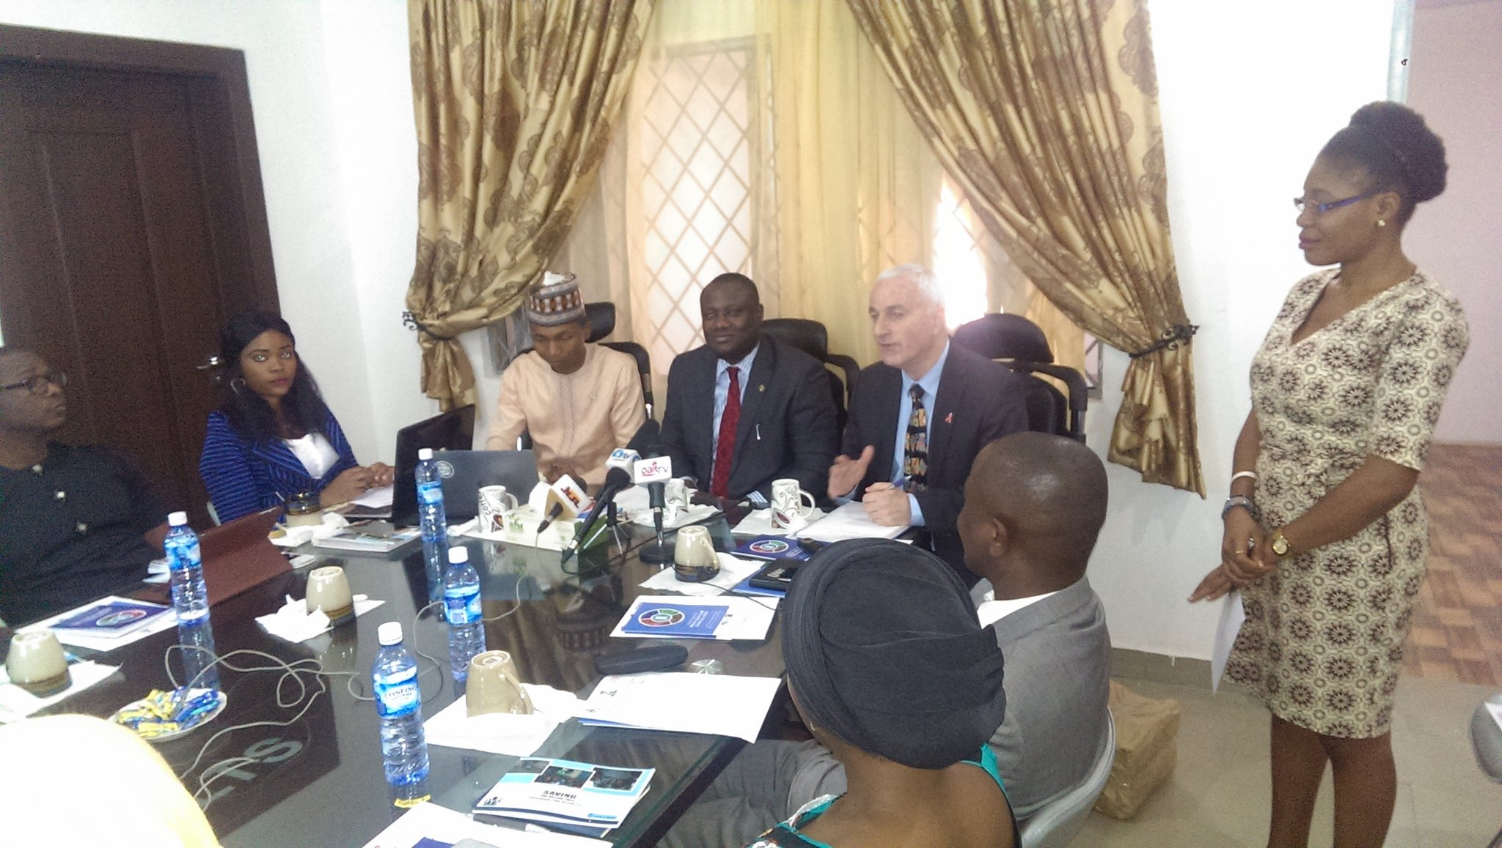
Cross Section of CSOs at the Roundtable Meeting - Photo Credit: CODE

Executive Summary
The roundtable discussion on Civil Society Organizations (CSOs) involvement in the Saving One Million Lives Program for Results [SOML PforR] was held in the conference room of the SOML PforR office on 13 April, 2017. In attendance were 36 participants including Dr Ibrahim Kana, the SOML PforR Lead at the Federal Ministry of Health; Hamzat Lawal, the Chief Executive of Connected Development [CODE]; and Dr Benjamin Loevinsohn, the SOML PforR Lead at the World Bank. Representatives of CSOs working in either intervention for direct provision of health services and/or monitoring at the community or rural level were also in attendance. The participants also included several media agencies. The discussion, which was initiated by CODE recognized the fact that there is a need for Civil Society to be carried along in the implementation processes of SOML PforR to create greater cohesiveness between all arms of the society (government, private sector and civil society).

A key point that came out of the roundtable was the fact that the goal of the SOML PforR is to improve the overall health system in states. As a result, states should see this as an opportunity to strengthen their health systems since they are getting the fund and are at liberty to spend it in improving the program’s Disbursement Linked Indicators without interference from the Federal Government.

All the organizations present agreed that the roundtable was a step in the right direction, especially in changing the narrative about the relationship between the government and civil society in the countr. This will not only serve as a form of checks and balances on both sides but will help to engender TRUST and the values of Open Government in the Nigerian society.

Background
In 2012, the Nigerian Federal Government initiated the Saving One Million Lives Program For Results (SOML PforR). The program intends to rollback child and maternal mortality in the country and save an estimated 900,000 women and children that die each year from preventable causes. In 2015, the World Bank approved $500 million credit for the program. Subsequently, in mid 2016, the World Bank provided $55.5 million as part of the credit to the Federal Ministry of Health who then gave $1.5 million to each of the 36 states and the Federal Capital Territory.

In line with Connected Development’s work in ensuring open government in governmental expenditure in rural communities and in our three thematic areas (which includes health), we immediately got interested in tracking the implementation of the funds across the country. On learning about the $55.5 million approval from the Bretton Woods Institution and in the last quarter of 2016, we started tracking the implementation of the $1.5 million at Primary Healthcare Centres across rural communities in Akwa Ibom, Enugu, Kano, Kogi, Osun and Yobe States. Subsequently, we arranged and had meetings with the World Bank and Federal Ministry of Health SOML PforR program team for information sharing and to share our experience in tracking the fund implementation. One of the key outcomes from these meetings is the importance of Civil Society Organisations involvement in the PforR implementation. It’s on this note that this CSOs roundtable was organized.

Objective of the workshop
To create a platform for civil society and government to interact on the SOML PforR implementation.
Opening Remarks
The event started at exactly 10 AM with introductions by all present. This was followed by welcome remarks by Dr Chima Elenwune, a Program Officer from the SOML PforR team. After this, Hamzat Lawal, the Chief Executive of CODE explained in detail the reason for and events that have led up to the roundtable and the major reason CSOs must get involved in the project.

Presentation by Dr Ibrahim Kana
The National Program Manager, Dr Ibrahim Kana, took the participants through a detailed illustration of the various models and the operational structures of SOML PforR, explaining in details, steps that have been put in place to ensure that the project hits its exact target with various parameters across all states of the federation and the FCT. He unpacked how the funds were disbursed and how it should be tracked to ensure targeted results are achieved. He further emphasized the need and importance of CSOs to engage in not just following the money but following results which birthed the hashtag #FollowTheResults. In addition, he added that the Paying for Results (P4R) approach was introduced as a tool structured toward redirecting the flow of resources to pay for results (desired goals, outcomes and impacts) rather than paying for inputs (processes or activity costs).

Comments/Recommendations and Information Sharing by CSOs
The CSOs present took turns to share their experiences on the work they have done so far regarding improving health outcomes around the country. They also took turns with the media this time, to ask Dr Kana key questions from his presentation. Most of the questions were on the progress of the program and extensive understanding on the steps taken in ensuring state governments do not waste the funds or under utilize them. The participant CSOs made various recommendations. The roundtable was very engaging and critical also, as commitments were made by CSOs present, the Media and SOML PforR team. All recommendations and commitments are documented in the communiqué that was read and agreed on by all present.

Key recommendations and commitments from CSOs present at the roundtable include:
i. A Coalition of CSOs for SOML PforR in Nigeria should be established to monitor the implementation of the SOML PforR in all 36 States and the FCT. The coalition should have sub-committees headed by chairs so that the CSOs can hold one another accountable and ensure that results come out of this coalition.

ii. A framework should be put in place for the involvement of the civil society at the states and community levels for the implementation of the SOML PforR. This will include community based organizations, community leadership associations, civil liberty organizations, and other key stakeholders as well as citizens. This will be kicked off with CSOs regional roundtables on the SOML PforR.

iii. A separate roundtable discussion should be organized for media engagement on the SOML PforR to bring a larger number of the media to understand how the program works so as to drive the correct messages to the public.

iv. As communities are the direct beneficiaries of majority of the program plans, they should be engaged effectively in the program implementation as a way to piggyback information and increase accountability and trust at all levels of the society.

Commitments from SOML PforR program team:

i. To see to the effective representation of the CSOs coalition through the coalition leadership at both the National and States Steering Committees of the SOML PforR;

ii. To continue to maintain an open-door policy and proactively engage the Civil Society and the media on issues concerning implementation of the SOML PforR

Commitments from the CSOs present:

CSOs present made specific commitments towards ensuring the growth and success of the activities of the aforementioned coalition. These commitments are listed below:

Connected Development

i. To host the next #FollowTheResults CSOs meeting to cover a larger body of Civil Society Organizations.

ii. To publish a shadow report on the work plans submitted by all the 36 States and the FCT outlining key recommendations.

iii. Building on her community reporting networks to host #FollowTheResults states and regional meetings.

Silver Lining for the Needy Initiative (SLNI)

i. To host the CSOs sub-committee meetings.

African Youth Initiative on Population, Health and Development
(AfryPOD)

i. To provide technical support to the CSOs coalition in the SOML PforR monitoring.

Public and Private Development Center (PPDC)

i. To provide radio airtime for SOML PforR on her BUDESHI radio platform on Nigerian Info.
Commitments from the media

iv. SilverBird TV made a commitment to host Dr Ibrahim Kana on a programme to educate the general public on the SOML PforR

Conclusion:
The roundtable ended in high spirits with the acceptance of the communiqué which was read to reflect all recommendations and commitments from the various discussions that took place.

Rapporteur Recommendation(s):
- More CSOs should be involved in later meetings and deliberations to get a more robust discussion and concrete commitments on CSOs involvement in the SOML PforR implementation.

Media Reports on the event:

- OAK TV:https://www.youtube.com/watch?v=fncFQkrs1iY and https://www.youtube.com/watch?v=uUDoLtUjqtc
- SILVERBIRD: https://www.youtube.com/watch?v=jXeBuVqmcbw

Attendance
In attendance were representatives of the following CSOs and Media:
- CODE
- WORLD BANK
- SOML/MINISTRY OF HEALTH
- PRIVATE AND PUBLIC DEVELOPMENT CENTRE
- KISS FM
- NIGERIA HEALTH WATCH
- AFRICAN YOUTH INITIATIVE ON POPULATION HEALTH & DEVELOPMENT
- THE PUNCH
- AFRICAN INDEPENDENT TELEVISION
- OAK TV
- NEWS AGENCY OF NIGERIA
- WAZOBIA FM
- SILVER LINING INITIATIVE
- AFRICAN YOUTH INITIATIVE ON PUBLIC HEALTH & DEVELOPMENT
- SILVER BIRD TELEVISION

